MODULE 1 - TUTORIAL / LABORATORY

Construction of a survey’s User Interface

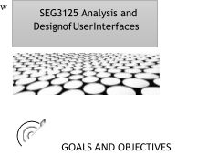This laboratory aims to build a static web page that lays out a survey to describe the user interface of a site of your choice. During this laboratory, you will need to:

* Get familiar with HTML and CSS for webpage building.
* Set up your site to demonstrate your practical work.



SUBMISSION DEADLINE

* + Friday, January 19, 2024, 11:59 p.m.



SUBMISSION METHOD

In Brightspace, In the Lab 1 submission link. Submit a pdf document consisting of the following:

1. Group number
2. Group members
3. Link to the private GitHub repository(don’t forget to add both the TA Gurdarshan:https://github.com/Gurdarshan-Singh and TA Anisha: <https://github.com/AnishaDeochake>)
4. Each members contribution.
5. Link to the website.
6. Snapshots of the website created

INSTRUCTIONS / TUTORIALS TO FOLLOW

* 1. 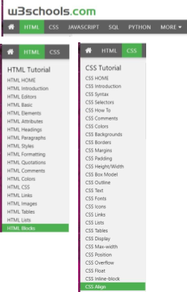You must first familiarize yourself with HTML/CSS. The [tutorial on the W3 School](https://www.w3schools.com/html/default.asp) website is really great. Take it one step at a time. You can't see everything, but look at least until the HTML Blocks part and until the CSS Align part.
  2. 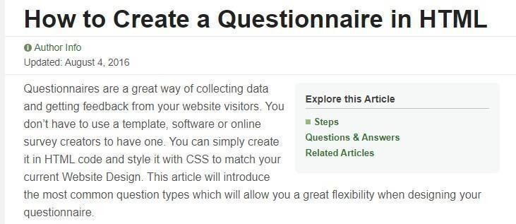Since the purpose of your lab is to build an HTML questionnaire, you can look at the following site:

[https://www.wikihow.com/Create-aQuestionnaire-in-HTML](https://www.wikihow.com/Create-a-Questionnaire-in-HTML)



Programming

* 1. Create your demonstration space for your labs/project. [Use GitHub Pages](https://pages.github.com/) that will allow you to have your own website at the address username.github.io.



Using HTML/CSS, you need to generate a static web page (which does not respond to actions) which is a survey of the user interface of a website of your choice. You decide for yourself which questions to ask.

Basic requirements of your page (Compulsory)

Your page should be minimally "pleasant to look at" and have some consistency (coherence). We will see throughout the semester different design principles, so this is only a firststep. Your page should contain:

* A title
* A link to the website
* An image of the page (UI to be evaluated) that also serves as a link to the website.
* A form containing at least 6 questions related to the evaluation of the Website: o A text-type question o Two single choice questions (radio button and a list) o A selection question (several boxes can be selected) o A space to write down comments.
* A button to submit the questionnaire.
* Your signature *(Website designed by ...)* at the bottom of the page.
* The use of <div> tags to make the questions uniform.
* Using external CSS (separate file) to set styles for titles, divisions, your signature at the bottom of the page. Explore font, color, alignment, etc. changes.

Additional possibilities (Optional)

* Allow the user to zoom in on part of the image.
* Use a photo gallery to show multiple pages of the site.
* Ask questions related to various images (various parts of a site)
* Use an image in the background to make the site prettier.
* Add any other HTML/CSS elements to improve the rendering of your survey and make people want to do it.

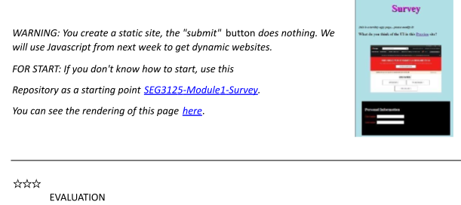

* + This lab is worth 3%.



Questions

You can also send your questions directly to Gurdarshan Singh (gsing189@uottawa.ca) or Anisha Deochake (adeoc086@uottawa.ca)